HON 3397J:
Extraordinary Leadership:
Ownership and Influence

Session Thirteen: Living a Story-Worthy Life

“And once you live a good story, you get a taste for a kind of meaning in life, and you can’t go back to being normal; you can’t go back to meaningless scenes stitches together by the forgettable thread of wasted time.”

Donald Miller

Abstract:
It was once said that those who change things live within earshot of their last terrifying moment. In this session, we will encourage you to adopt the mindset of taking risks and being action-oriented. With paired readings and case studies on individuals and organizations that have chosen to live boldly, Session Eleven is intended to drive you toward your next big thing.

Objectives:
By the end of this session, students will be able to:
- Identify areas in their life where they should take greater risks
- Combine purpose and passion in their lives
- Understand the key elements of the Hero's Journey
- Plan for designing a story worthy life

AFTER PRE-READING:

Health-Work-Play-Love Balance
Mark your dashboard as it currently exists. If you could make one incremental adjustment, what would it be? Redraw your improved dashboard.
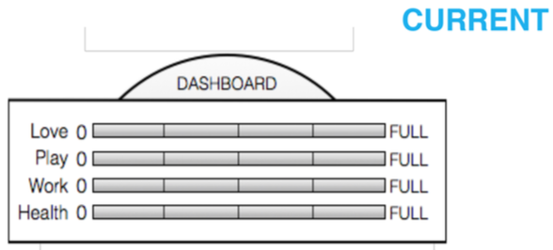
What do you observe (and are you being fair)?
____________________________________________________________________________
____________________________________________________________________________
If you could make one incremental adjustment, what would it be? Redraw your improved dashboard.
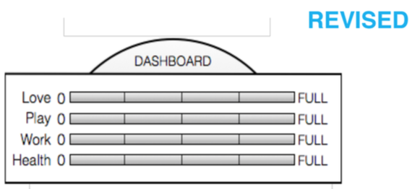
What would you get if you could attain this revised level of balance? How would life (really) change for you?
____________________________________________________________________________
____________________________________________________________________________
What incremental change could you attempt to move in this direction? What would it take for you to live this way for two weeks?
____________________________________________________________________________
____________________________________________________________________________
Odyssey Planning 101
Using what you read in the Design Your Lives reading to create three alternate versions of the next five years of your life. Feel free to reference the example in the reading. Each one must include:
- A visual/graphical timeline. Include personal and non-career events as well - do you want to be married, train to win the CrossFit Games, or learn how to bend spoons with your mind?
- A title for each option in the form of a six-word headline describing the essence of this alternative.
- Questions that this alternative is asking - preferably two or three. A good designer asks questions to test assumptions and reveal new insights. In each potential timeline, you will investigate different things about yourself and the world. What kinds of things will you want to test and explore in each alternative version of your life?
- A dashboard where you can gauge:
  - Resources: Do you have the objective resources - time, money, skill, contacts - you need to pull off your plan?
  - Likability: Are you hot or cold or warm about your plan?
  - Confidence: Are you feeling full of confidence or pretty uncertain about pulling this off?
  - Coherence: Does this plan make sense within itself? And is it consistent with you, your workview and your lifeview?
- Possible Considerations:
  - Geography - where will you live?
  - What experience or learning will you gain?
  - What are the impacts/results of choosing this alternative?
  - What will life look like? What particular role, industry or company do you see yourself in?
- Other ideas
  - Do keep in mind things other than career and money. Even though those things are important, if not central, to the decisive direction of your next few years, there are other critical elements that you want to pay attention to.
  - Any of the considerations listed above can be a springboard for forming your alternative lives for the next five years. If you find yourself stuck, try making a mind map out of any of the design considerations listed above. Don’t overthink this exercise.
Be sure to complete this in detail. You will present it in class.

Use the below charts to plan your three alternate lives as discussed in the reading:

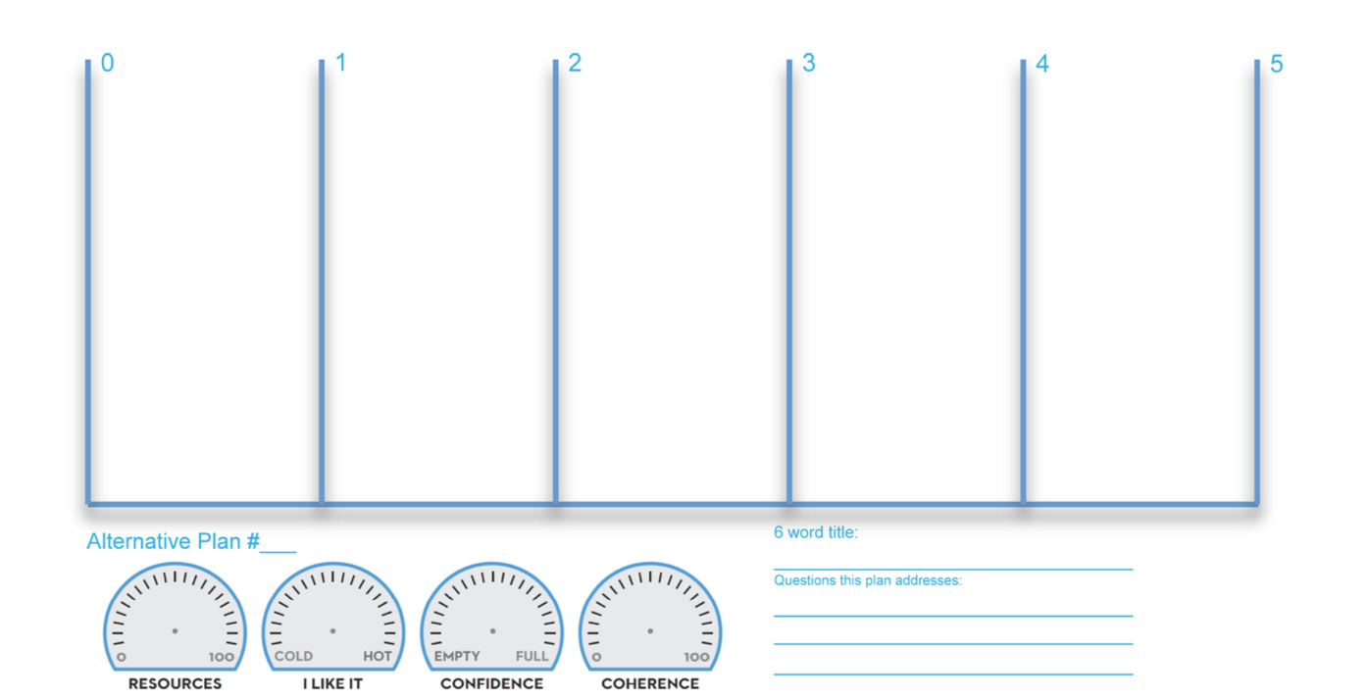

IN CLASS WORK:

Live a Story-Worthy Life

The Hero’s Journey.
Most, if not all, of our favorite books, movies, plays, and stories have main characters who follow the Hero’s Journey. All the characters who matter, the ones who we love and root for, have been through hell and come back changed and better equipped for success. When you look back over your life, don’t you want to see a series of memorable moments that make up a story worth telling?

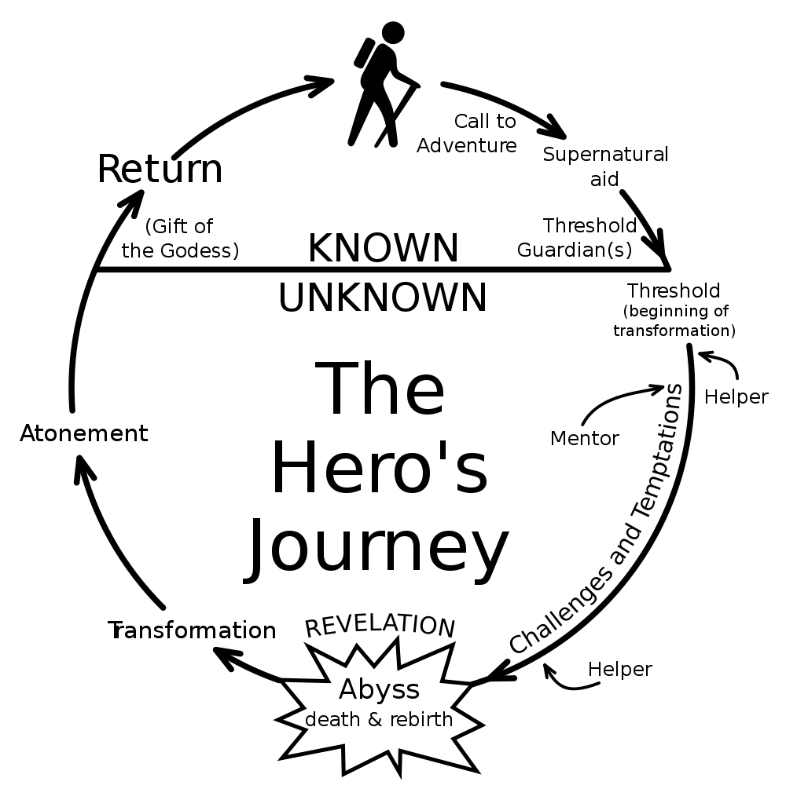

High Points
Today

Birth
Low Points
What themes or connections can you make with your high points?

____________________________________________________________________________
____________________________________________________________________________
____________________________________________________________________________
____________________________________________________________________________
____________________________________________________________________________
____________________________________________________________________________

What themes or connections can you make with your low points?

____________________________________________________________________________
____________________________________________________________________________
____________________________________________________________________________
____________________________________________________________________________
____________________________________________________________________________
____________________________________________________________________________

What habits can you add to your daily life to create more of those memorable moments?

____________________________________________________________________________
____________________________________________________________________________
____________________________________________________________________________
____________________________________________________________________________
Heroes We Admire

Know where they’re from – they know how their background story affects who they are.

Are self-aware – they know who they are, or are in the middle of figuring it out. Reflection is hard work most won’t choose to do.

Hone their strengths – they know what makes them come alive and pursue it with ruthless focus.

Choose to be extraordinary – they create habits that others don’t have. They wake up earlier, do things others aren’t willing to do and validate themselves.

Have influence – they possess the tools to lead people and adapt their style to motivate others.

Core Tenet

“It is not the critic who counts; not the man who points out how the strong man stumbles, or where the doer of deeds could have done them better. The credit belongs to the man who is actually in the arena, whose face is marred by dust and sweat and blood; who strives valiantly; who errs, who comes short again and again, because there is no effort without error and shortcoming…”

~Theodore Roosevelt

POST-CLASS WORK:

Planning backwards
This activity is based on the Session Thirteen post-reading, “Stars and Stepping Stones” by Jeff Sandefer. Read the article and complete the activity below.
Seventy to Fifty
____________________________________________________________________________
____________________________________________________________________________
____________________________________________________________________________
____________________________________________________________________________
____________________________________________________________________________
____________________________________________________________________________
____________________________________________________________________________
____________________________________________________________________________
____________________________________________________________________________
____________________________________________________________________________
____________________________________________________________________________
____________________________________________________________________________
____________________________________________________________________________
____________________________________________________________________________
____________________________________________________________________________
____________________________________________________________________________
____________________________________________________________________________
____________________________________________________________________________
____________________________________________________________________________
Planning backwards (continued)
Fifty to Thirty
____________________________________________________________________________
____________________________________________________________________________
____________________________________________________________________________
____________________________________________________________________________
____________________________________________________________________________
____________________________________________________________________________
____________________________________________________________________________
____________________________________________________________________________
____________________________________________________________________________
____________________________________________________________________________
____________________________________________________________________________
____________________________________________________________________________
____________________________________________________________________________
____________________________________________________________________________
____________________________________________________________________________
____________________________________________________________________________
____________________________________________________________________________
____________________________________________________________________________
____________________________________________________________________________
____________________________________________________________________________
____________________________________________________________________________
____________________________________________________________________________
Planning backwards (continued)
Thirty to Today
____________________________________________________________________________
____________________________________________________________________________
____________________________________________________________________________
____________________________________________________________________________
____________________________________________________________________________
____________________________________________________________________________
____________________________________________________________________________
____________________________________________________________________________
____________________________________________________________________________
____________________________________________________________________________
____________________________________________________________________________
____________________________________________________________________________
____________________________________________________________________________
____________________________________________________________________________
____________________________________________________________________________
____________________________________________________________________________
____________________________________________________________________________
____________________________________________________________________________
____________________________________________________________________________
____________________________________________________________________________
____________________________________________________________________________
____________________________________________________________________________

Notes and Thoughts
____________________________________________________________________________
____________________________________________________________________________
____________________________________________________________________________
____________________________________________________________________________
____________________________________________________________________________
____________________________________________________________________________
____________________________________________________________________________
____________________________________________________________________________
____________________________________________________________________________
____________________________________________________________________________
____________________________________________________________________________
____________________________________________________________________________
____________________________________________________________________________
____________________________________________________________________________
____________________________________________________________________________
____________________________________________________________________________
____________________________________________________________________________
____________________________________________________________________________
____________________________________________________________________________
____________________________________________________________________________
____________________________________________________________________________
____________________________________________________________________________

